

CSc 131 SW Engineering:

Software Requirement Specification (SRS)

Revision History

Revision # | Revision date | Revised by | Revision(s)
0.1 | 3/3/ | B. J. | Project deliverable 2.1: Drafted initial document. Added new (JHA) logo—designed by M. Hyatt—to cover page. Added sections 1-2.
0.2 | 3/18/ | B. J.  M. H.  M. A. | Project deliverable 2.2: Refined sections 1-2. Added sections 3-8.

Table of Contents

1 Introduction 7
1.1 Purpose of this Document 7
1.2 Scope of the Development Project 7
1.2.1 Product 7
1.2.2 Function 7
1.2.3 Distinct Features 7
1.2.4 Limitations 8
1.3 Overview of Document 8
1.3.1 Notes on Convention 8
2 General Description 9
2.1 Glossary 9
2.1.1 Terminology 9
2.1.2 Abbreviations 10
2.1.3 Acronyms 10
2.2 User Characteristics 11
2.3 Product Perspective 11
2.4 Overview of Functional Requirements 11
2.4.1 Client Management 12
2.4.1.1 Client/Child Intake 12
2.4.1.1.1 HMIS Client Questionnaire 12
2.4.1.1.2 HMIS Child Questionnaire 12
2.4.1.1.3 Additional Client Information Form 12
2.4.1.2 Client/Child Outlet 12
2.4.1.2.1 HMIS Client Questionnaire 12
2.4.1.2.2 HMIS Child Questionnaire 12
2.4.1.3 Client 13
2.4.1.3.1 Modify Client 13
2.4.1.3.2 Delete Client 13
2.4.1.3.3 Modify Child 13
2.4.1.3.4 Delete Child 13
2.4.1.4 Report Generation 13
2.4.1.4.1 Daily Client List 13
2.4.1.4.2 Daily Vacancy List 13
2.4.1.4.3 Weekly Chore List 13
2.4.1.4.4 Periodic HMIS Summary 14
2.4.1.4.5 DA-4 Grant Summary 14
2.4.1.5 Query Interface 14
2.4.1.5.1 Manage Queries 14
2.4.1.5.2 Execute Queries 14
2.4.2 Donor Management 14
2.4.2.1 Gifts 14
2.4.2.1.1 Add Gift 15
2.4.2.1.2 Modify Gift 15
2.4.2.2 Donors 15
2.4.2.2.1 Add Group 15
2.4.2.2.2 Modify Group 15
2.4.2.2.3 Add Individual 15
2.4.2.2.4 Modify Individual 15
2.4.2.3 Mail Merges 15
2.4.2.3.1 Solicitation 15
2.4.2.3.2 Thank You Letters 16
2.4.2.3.3 Criteria-Based Merge 16
2.4.2.4 Report Generation 16
2.4.2.4.1 Monthly/Periodic Donor Gift Report 16
2.4.2.4.2 Demographic Report 16
2.4.2.5 Query Interface 16
2.4.2.5.1 Manage Queries 16
2.4.2.5.2 Execute Queries 16
2.5 General Constraints & Assumptions 17
2.5.1 Constraints 17
2.5.1.1 HW Constraints 17
2.5.1.2 SW Constraints 17
2.5.1.3 Network Constraints 17
2.5.1.4 Environmental Constraints 17
2.5.1.5 Compliance with Relevant Standards 17
2.5.2 Assumptions 18
2.5.2.1 HW Assumptions 18
2.5.2.2 SW Assumptions 18
2.6 User’s View of Product 18
2.6.1 Login Screen 18
2.6.2 HMIS Client Form 19
3 Specific Requirements 19
3.1 Interface Requirements 19
3.1.1 User Interface 19
3.1.2 Software Interface 19
3.1.3 Hardware Interface 20
3.1.4 Communication Interface 20
3.2 Detailed Description of Functional Requirements 20
3.2.1 Client Management 21
3.2.1.1 Client/Child Intake 21
3.2.1.1.1 HMIS Client Questionnaire 21
3.2.1.1.2 HMIS Child Questionnaire 21
3.2.1.1.3 Additional Client Information Form 22
3.2.1.2 Client/Child Outlet 22
3.2.1.2.1 HMIS Client Questionnaire 22
3.2.1.2.2 HMIS Child Questionnaire 22
3.2.1.3 Client 22
3.2.1.3.1 Modify Client 22
3.2.1.3.2 Delete Client 23
3.2.1.3.3 Modify Child 23
3.2.1.3.4 Delete Child 23
3.2.1.4 Report Generation 23
3.2.1.4.1 Daily Client List 23
3.2.1.4.2 Daily Vacancy List 24
3.2.1.4.3 Weekly Chore List 24
3.2.1.4.4 Periodic HMIS Summary 24
3.2.1.4.5 DA-4 Grant Summary 24
3.2.1.5 Query Interface 25
3.2.1.5.1 Manage Queries 25
3.2.1.5.2 Execute Queries 25
3.2.2 Donor Management 25
3.2.2.1 Gifts 26
3.2.2.1.1 Add Gift 26
3.2.2.1.2 Modify Gift 26
3.2.2.2 Donors 26
3.2.2.2.1 Add Group 26
3.2.2.2.2 Modify Group 26
3.2.2.2.3 Add Individual 27
3.2.2.2.4 Modify Individual 27
3.2.2.3 Mail Merge 27
3.2.2.3.1 Solicitation 27
3.2.2.3.2 Thank You Letters 27
3.2.2.3.3 Criteria-Based Merge 28
3.2.2.4 Report Generation 28
3.2.2.4.1 Monthly/Periodic Donor Gift Report 28
3.2.2.4.2 Demographic Report 28
3.2.2.5 Query Interface 29
3.2.2.5.1 Manage Queries 29
3.2.2.5.2 Execute Queries 29
3.2.3 Data Dictionary 30
3.3 Non-Functional Requirements 31
3.4 Other Requirements 31
4 Object Oriented Analysis (OOA) –UML 31
4.1 OOA 31
4.1.1 Use Case Diagram 31
4.1.2 Use Case Descriptions 32
4.1.2.1 Client/Child Intake 32
4.1.2.1.1 Typical Flow Description: 33
4.1.2.1.2 Alternative Flow Description: 33
4.1.2.2 Client/Child Outlet 34
4.1.2.2.1 Typical Flow Description: 34
4.1.2.2.2 Alternative Flow Description: 35
4.1.2.3 Client Information Management 35
4.1.2.3.1 Typical Flow Description: 36
4.1.2.3.2 Alternative Flow Description: 37
4.1.2.4 Client Report Generation 37
4.1.2.4.1 Typical Flow Description: 38
4.1.2.4.2 Alternative Flow Description: 39
4.1.2.5 Donor Gift (Donation) Management 39
4.1.2.5.1 Typical Flow Description: 40
4.1.2.5.2 Alternative Flow Description: 41
4.1.2.6 Donor Management 41
4.1.2.6.1 Typical Flow Description: 42
4.1.2.6.2 Alternative Flow Description: 43
4.1.2.7 Mail Merge System 43
4.1.2.7.1 Typical Flow Description: 44
4.1.2.7.2 Alternative Flow Description: 45
4.1.2.8 Donor Report Generation 45
4.1.2.8.1 Typical Flow Description: 46
4.1.2.8.2 Alternative Flow Description: 46
4.1.2.9 Query Database 46
4.1.2.9.1 Typical Flow Description: 47
4.1.2.9.2 Alternative Flow Description: 48
4.1.3 Potential Classes 48
4.1.3.1 Client 48
4.1.3.2 Child 49
4.1.3.3 Individual Donor 49
4.1.3.4 Group Donor 49
4.1.3.5 Report 49
4.1.3.6 Gift 49
5 WBS 50
6 Comments 50
6.1 Issues 50
6.2 Notes 50
7 References 50
8 Resources 51

Tables

Table 3.2.3-1: Data Dictionary 30
Table 5-1: Work Breakdown Structure 50

Figures

Figure 2.6.1-1: User’s view of SJS CDMS Login Screen 18
Figure 2.6.2-2: User’s view of SJS CDMS HMIS Client Questionnaire 19
Figure 3.2-1: High-level view of Functional Requirements 20
Figure 4.1.1-1: Use Case Diagram 32
Figure 4.1.2.1.1-2: Typical flow of Client/Child Intake 33
Figure 4.1.2.1.2-3: Alternative flow of Client/Child Intake 33
Figure 4.1.2.2.1-4: Typical flow of Client/Child Outlet 34
Figure 4.1.2.2.2-5: Alternative flow of Client/Child Outlet 35
Figure 4.1.2.3.1-6: Typical flow of Client Information Management 36
Figure 4.1.2.3.2-7: Alternative flow of Client Information Management 37
Figure 4.1.2.4.1-8: Typical flow of Client Report Generation 38
Figure 4.1.2.4.2-9: Alternative flow of Client Report Generation 39
Figure 4.1.2.5.1-10: Typical flow of Donor Gift Management 40
Figure 4.1.2.5.2-11: Alternative flow of Donor Gift Management 41
Figure 4.1.2.6.1-12: Typical flow of Donor Management 42
Figure 4.1.2.6.2-13: Alternative flow of Donor Management 43
Figure 4.1.2.7.1-14: Typical flow of Mail Merge System 44
Figure 4.1.2.7.2-15: Alternative flow of Mail Merge System 45
Figure 4.1.2.8.1-16: Typical flow of Donor Report Generation 46
Figure 4.1.2.9.1-17: Typical flow of Query Database 47
Figure 4.1.2.9.2-18: Alternative flow of Query Database 48

Introduction

Purpose of this Document

This SRS describes the functions and performance requirements allocated to the St. John’s Shelter client/donor information management system.

Scope of the Development Project

The scope of our project is defined by our product, its functionality, features, and limitations.

Product

We’ve defined our product as a “Client/Donor Information Management System.”

Function

Our product will perform the function of managing client needs as well as donor information as such pertains to the St. John’s Shelter.

Distinct Features

Our product incorporates the following distinct features:

- Data acquisition
- Report generation
- Potential to interface with other systems (e.g., HUD)
- Resource allocation
- Optional features
  - Incremental save

Limitations

- N/A

Overview of Document

The following document provides the reader with a specification outlining the general as well as specific SW requirements required in order to successfully develop our product. These requirements are those specified by St. John’s Shelter for Women & Children (whom we will interchangeably refer to as St. John’s Shelter, St. John’s or just simply SJS throughout this document), and are documented to the full extent of which we could interpret them.

First, we will provide the reader with a general description (see Section 2: General Description) of our product, within which we will define certain jargon affiliated with such, and user characteristics. This general description will also provide the reader with a perspective from the point of view of our product, an overview of functional requirements and a user view of product use.

We will then delve into the specific requirements (see Section 3: Specific Requirements) associated with our product. Here we will include interface requirements and a detailed description of functional requirements as well as outline non-functional requirements.

Finally, we will provide the reader with an object oriented view of our project which will include and analysis of such (see Section 4: Object Oriented Analysis). Diagrams/drawings will hopefully assist the reader in viewing the overall layout of our project.

Notes on Convention

- When we refer to the term user, we are referring to the client-side of a client/server connection. When we refer to the term client, we are referring to either St. John’s clients (meaning the women and children residing there) or the employees of St. John’s Shelter whom we are servicing with this product.

- When necessary, we will explicitly state the client (woman) and child as two separate entities; clients have a different intake form than children do.

- All terms italicized are defined in the terminology section of our glossary. (see Section 2.1: Glossary)

- Words/phrases proceeded by a subscript_{x} are explained in the Notes section at the end of this document. (see Section 6.2: Notes)

General Description

The following serves as a general description of our product and its purpose is to give the reader an “executive overview.” Furthermore, the following is user-oriented.

Glossary

For the convenience of the user, we’ve entailed the proceeding sub-sections which define the terms, abbreviations and acronyms used within this document.

Terminology

Actor A coherent set of roles that users of use cases play when interacting with these use cases; represents anything that interacts with system.

Abstraction A simplified representation of something that is potentially quite complex.

Attribute A description of the characteristics of the object; usually appears in OOA as adjectives.

Class A description of a set of objects that share the same attributes operations, relationships, and semantics.

Client An occupant of St. John’s Shelter; St. John’s Shelter.

Entity A data object; producer/consumer of information outside the bounds of the system.

Incremental Recording method allowing subsequent append or overwrite operations without reformatting or loss of adjacent pre-recorded information.

Intranet A private network inside a company or organization that uses the same kinds of software that you would find on the public Internet, but only for internal use.

Method A function (subroutine) associated with an object; usually appears in OOA as verbs.

Object Referring to a software object, correlates to real-world object in that they, too, have state and behavior; usually appears in OOA as nouns; An instance of a class.

Use Case A sequence of actions, including variants, that a system (or other entity) can perform, interacting with actors of the system.

User As pertains to the client-side of a client/server connection.

Workstation A computer connected to a network at which users interact with software stored on the network.

Abbreviations

App Application
E.g. For example (Latin: "exemplum gratii")
DB Database
I.e. That is (Latin: "id est")

Acronyms

CDMS Client/Donor Management System
CSV Comma Separated Values
DA-4 Community Services Block Grant Application (Form DA-4)
HMIS Homeless Management Information Strategies
HTML Hyper-Text Markup Language
HUD Housing & Urban Development
HW Hardware
LAN Local Area Network
N/A Not/Non Applicable
OOA Object Oriented Analysis
PC Personal Computer
SJS St. John’s Shelter (for Women & Children)
SRS Software Requirement Specification
SW Software
TBD To Be Determined
UML Unified Modeling Language

User Characteristics

This product is intended for the exclusive use of St. John’s Shelter employees. Moreover, the human interface will incorporate the following characteristics:

- User access management
- File access management
  - File level password-protection
- Task oriented
- Mirror current procedures and layouts as close as possible

Product Perspective

From the perspective of the product, it will interface with 7-10 PC’s on an Intranet as well as with the existing HUD system. Furthermore, the product should:

- Run on an outdated₁ server
  - Server must meet minimum SW packages upon which our product depends on.
- Run on an outdated workstation
  - Workstation must meet minimum SW packages upon which our product depends on.
    - E.g., HTML browser, etc.

Overview of Functional Requirements

The following section should provide the reader with a high-level view of the functions to be performed by our product. For a more detailed description of such functions the reader should refer to Section 3.2 of this document.

As a team we sat down and asked ourselves, “What exactly should this information management system do? What functions will it provide?” After hours of brainstorming, coupled with meetings with the client, we came up with the following to define a high-level overview of our functional requirements.

Client Management

One main function of our product will be to serve as a Client Management system. As such a system, our product will be responsible for facilitating the management of information as it pertains to the clients of SJS. The following subsections represent sub-functions that this facet of the overall system will manage.

Client/Child Intake

Facilitate the intake of new and returning clients/children.

HMIS Client Questionnaire

The HMIS Client Questionnaire necessary for the intake of clients. To be submitted to HUD and stored in a local database for report generation.

HMIS Child Questionnaire

The HMIS Client Questionnaire necessary for the intake of children.

Additional Client Information Form

Information not included on the HMIS Client Questionnaire necessary to generate required reports.

Client/Child Outlet

Information included in the HMIS Client Questionnaire necessary for clients/children leaving St. John's Shelter.

HMIS Client Questionnaire

The HMIS Client Questionnaire necessary for the outlet of clients. To be submitted to HUD and stored in a local database for report generation.

HMIS Child Questionnaire

The HMIS Client Questionnaire necessary for the outlet of children.

Client

Modify Client

Modify an existing client record.

Delete Client

Delete an existing client record.

Modify Child

Modify an existing child record.

Delete Child

Delete an existing child record.

Report Generation

Reports are generated from the HMIS Client Questionnaire, HMIS Child Questionnaire, and Additional client information form.

Daily Client List

A list generated on a daily basis which is composed of current clients and their respective bed assignments.

Daily Vacancy List

A list generated on a daily basis from the HMIS Client Questionnaire, HMIS Child Questionnaire, and Daily Client List.

Weekly Chore List

A list generated on a weekly basis from the HMIS Client Questionnaire, HMIS Child Questionnaire, and Additional Client Information form.

Periodic HMIS Summary

A report generated—on a periodic basis—for HUD from the HMIS Client Questionnaire, and HMIS Child Questionnaire.

DA-4 Grant Summary

A report generated from the HMIS Client/Child Questionnaire regarding eligibility for the DA-4 Grant.

Query Interface

An interface utilized to facilitate criteria-based retrieval as well as the viewing of stored client records.

Manage Queries

A sub-interface utilized to create, modify, and/or delete database queries.

Execute Queries

Facilitate the query-based retrieval and viewing of stored client records.

Donor Management

Another main function of our product will be to serve as a Donor Management system. As such a system, our product will be responsible for facilitating the management of information as it pertains to donors as well as the gifts (donations) that they bequeath to SJS. The following subsections represent sub-functions that this facet of the overall system will manage:

Gifts

Anything in the form of a donation bestowed upon the St. John's Shelter.

Add Gift

Create a new gift and associate it with a certain individual or group.

Modify Gift

Edit the properties of an existing gift.

Donors

Individuals or groups that represent a donor (or prospective donor) fall into the proceeding section.

Add Group

Create a new group₂ of donors.

Modify Group

Modify an existing group of donors.

Add Individual

Add a new individual donor and optionally associate with a group.

Modify Individual

Modify an existing individual donor.

Mail Merges

Use information stored within database to generate mass mailings or summaries.

Solicitation

Generate mass mailing letters and respective envelopes for use in soliciting funds, gifts/donations.

Thank You Letters

Generate thank you letters and respective envelopes.

Criteria-Based Merge

Generate mail merge data based on a given criteria.

Report Generation

Reports generated from all pertinent donor information stored within database.

Monthly/Periodic Donor Gift Report

A report generated—on a monthly and/or periodic basis—from stored gift information.

Demographic Report

A report generated from stored individual and/or group donor information (that will aid in determining the demographics of likely donors).

Query Interface

An interface utilized to facilitate the criteria-based retrieval and viewing of stored donor and gift records.

Manage Queries

An interface utilized to create, modify, and delete database queries.

Execute Queries

Facilitate the query-based retrieval and viewing of stored donor and gift records.

General Constraints & Assumptions

Before we can proceed with the implementation phase of our product we realize the necessity to delineate all constraints and assumptions that may obstruct our progress in an effort to resolve them before they become an issue. Knowing this, as a group we sat down and came up with the following as a list of possible constraints and assumptions.

Constraints

HW Constraints

- Possible legacy issues?
  - PC’s on intranet are running Windows 98.
  - Server is running Windows 2000 Pro.

SW Constraints

- Possible legacy issues?
  - PC’s on intranet are running Windows 98.
  - Server is running Windows 2000 Pro.

Network Constraints

- Adequate network?

Environmental Constraints

- N/A

Compliance with Relevant Standards

- HUD HMIS interface?
  - When interfacing with HUD HMIS Client Questionnaire we may be limited to a certain amount of functionality.
- HW performance?
  - PC’s on intranet are running no better than Pentium III processors; memory/speed could be possible issues.

Assumptions

HW Assumptions

- We assume that all hardware (e.g., workstations and server) will be operable.

SW Assumptions

- We assume that all dependent software packages (e.g., HTML browser and web server app’s) will be present and operable.

User’s View of Product

The following serves the reader as a “user’s-eye-view” of our product, if you will.

Login Screen

Figure 2.6.1-1: User’s view of SJS CDMS Login Screen
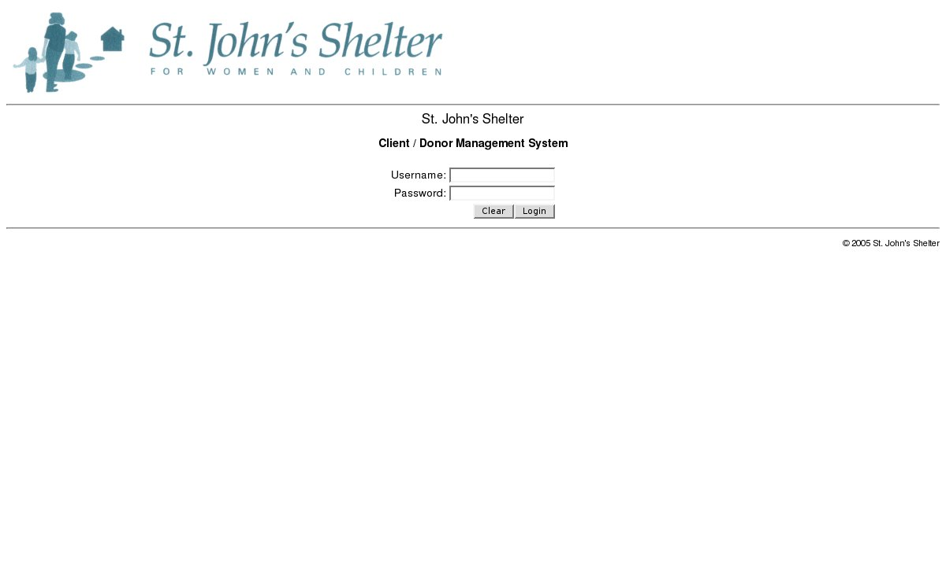

HMIS Client Form

Figure 2.6.2-2: User’s view of SJS CDMS HMIS Client Questionnaire
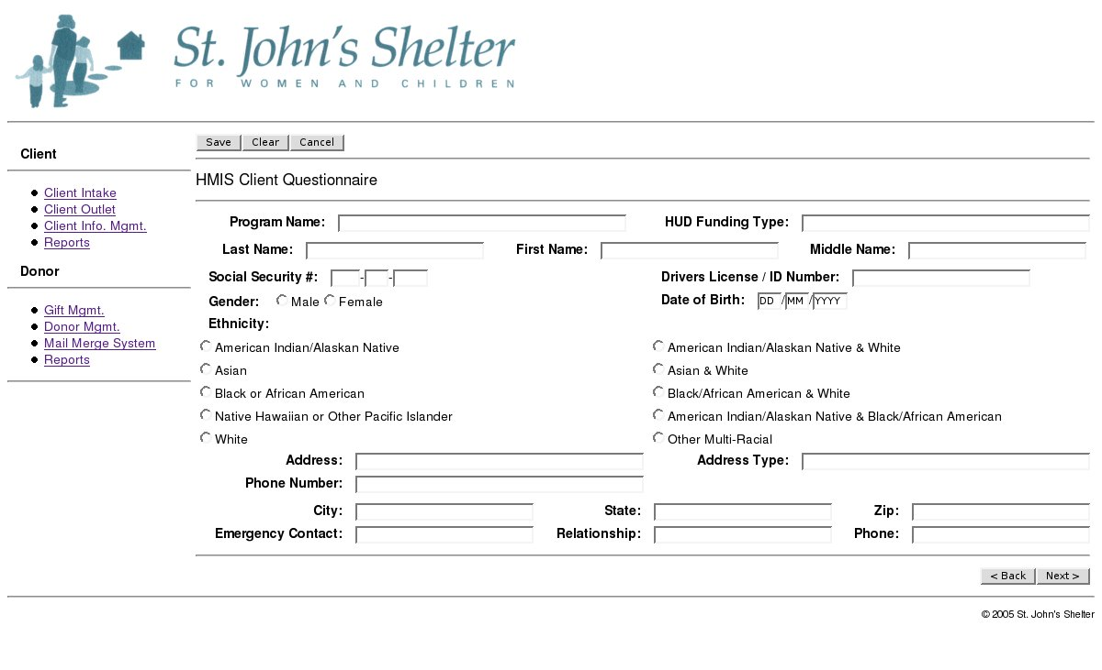

Specific Requirements

The following serves as a technical specification of our product.

Interface Requirements

Our system will be composed of user, hardware, software and communication interfaces. The proceeding outlines such:

User Interface

The user interface will be a Web-based application. Moreover, the user interface is a Web browser capable of forms that will interface with software.

Software Interface

The software interface is represented by a Web browser as well as pertinent software packages that will allow the user to interface with hardware.

Hardware Interface

The hardware interface is represented by a workstation that will connect to the existing St. John’s intranet (plus mouse and keyboard).

Communication Interface

The communication interface will be one of client/server interaction through a LAN connection; will provide an interface between hardware entities.

Detailed Description of Functional Requirements

In section 2.4 we gave the reader an overview of the functional requirements of our product. In the section to follow, we will delve into each requirement and provide the reader with a more in-depth description of such. We will then outline a data dictionary which serves the purpose of supplying pertinent data information (i.e., how data is used) that accompanies our functional requirements.

Before we probe deeper into the functional specifications, we thought that it would be beneficial to the reader to view this entire system from a high-level; thus, we’ve entailed the following diagram to aid the reader in doing such.

Figure 3.2-3: High-level view of Functional Requirements
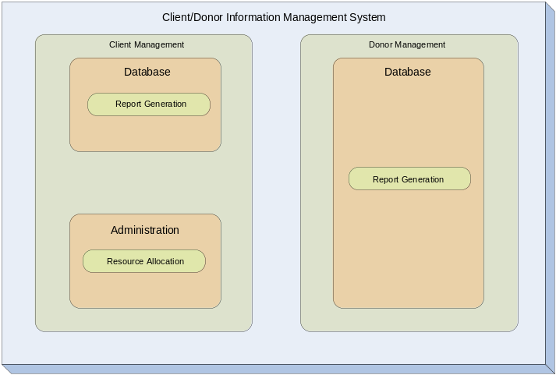

As one can gather from the preceding figure, from the highest level of abstraction our product is composed of two main functions: On one hand it operates as a database which integrates client and donor information from which it can generate reports (i.e., run queries/sorts), and on the other hand it will operate as an administration system that will administer such duties as allocating resources (i.e., room assignments, chores) for the clients within the system.

Client Management

Under client management falls four pertinent sub-functions to ensure that the entire system operates properly. We’ve defined them as Client/Child Intake, Client/Child Outlet, Report Generation, and Query Interface. In addition, each one of these sub-functions (likely) has respective sub-functions. We will provide a detailed description of these “sub-sub-functions” in the following format:

- Purpose/Description
- Inputs
- Defines inputs, and from what sources such input will be derived.
- Processing
- Description of outcome, including any validity checks on the data.
- Outputs
- Defines process by which the output is stored.
- Defines process for handling error messages produced as output.

Client/Child Intake

HMIS Client Questionnaire

- Purpose/Description: Allows clients to be input into the client database.
- Inputs:
  - HMIS client questionnaire form
- Processing: Performs sanity₄ checks on client data.
- Outputs: Commits client record to the database.

HMIS Child Questionnaire

- Purpose/Description: Allows children to be input into the client database and associated with a client.
- Inputs:
  - HMIS child questionnaire form
  - Client association
- Processing: Performs sanity checks on child data.
- Outputs: Commits child record to the database.

Additional Client Information Form

- Purpose/Description: Allows additional information to be added to an existing client.
- Inputs:
  - Existing client record
  - Additions made to client questionnaire
- Processing: Performs sanity checks on additional client information data.
- Outputs: Commits updated client record to the database.

Client/Child Outlet

HMIS Client Questionnaire

- Purpose/Description: Allows client outlet data to be input into the client database.
- Inputs:
  - HMIS client questionnaire form
- Processing: Performs sanity₄ checks on client data.
- Outputs: Commits client record to the database.

HMIS Child Questionnaire

- Purpose/Description: Allows children outlet data to be input into the client database and associated with a client.
- Inputs:
  - HMIS child questionnaire form
  - Client association
- Processing: Performs sanity checks on child data.
- Outputs: Commits child record to the database.

Client

Modify Client

- Purpose/Description: Allows client information to be modified within database.
- Inputs:
  - Client record (HMIS client form & Additional Information Form)
- Processing: Performs sanity checks on client record.
- Outputs: Commits modified client record to the database.

Delete Client

- Purpose/Description: Allows client record to be deleted from database.
- Inputs:
  - Client
- Processing: Performs sanity checks on client record.
- Outputs: N/A.

Modify Child

- Purpose/Description: Allows child information to be modified within database.
- Inputs:
  - Child record (HMIS child form)
- Processing: Performs sanity checks on child record.
- Outputs: Commits modified child record to the database.

Delete Child

- Purpose/Description: Allows child record to be deleted from database.
- Inputs:
  - Child
- Processing: Performs sanity checks on child record.
- Outputs: N/A.

Report Generation

Daily Client List

- Purpose/Description: Allows for the generation of a daily client list.
- Inputs:
  - Existing client record
- Processing: N/A
- Outputs: Report data (CSV).

Daily Vacancy List

- Purpose/Description: Allows for the generation of a daily vacancy list.
- Inputs:
  - Daily client list
- Processing: Performs sanity check on criteria-based additional client information.
- Outputs: Report data (CSV).

Weekly Chore List

- Purpose/Description: Allows for the generation of a weekly chore list.
- Inputs:
  - Daily client list
  - Additional client information
- Processing: Performs sanity check on criteria-based additional client information.
- Outputs: Report data (CSV).

Periodic HMIS Summary

- Purpose/Description: Allows for the generation of a periodic HMIS summary.
- Inputs:
  - HMIS client questionnaire
  - HMIS child questionnaire
  - Daily client list
- Processing: N/A
- Outputs: Report data (CSV).

DA-4 Grant Summary

- Purpose/Description: Allows for the generation of a DA-4 grant summary.
- Inputs:
  - Existing client record
- Processing: N/A
- Outputs: Report data (CSV).

Query Interface

Manage Queries

- Purpose/Description: Allows for the management as well as creation of queries.
- Inputs:
  - Query builder form
  - Query management form
- Processing: Performs sanity check on query builder form as well as query management form.
- Outputs: Commits query record to the database.

Execute Queries

- Purpose/Description: Allows for the execution of pre-built as well as ad-hoc queries.
- Inputs:
  - Query execution form
- Processing: Performs sanity check on query execution form.
- Outputs: Query result (in a summary/detail format).

Donor Management

Under donor management falls five pertinent sub-functions to ensure that the entire system operates properly. We’ve defined them as Gifts, Donors, Mail Merges, Report Generation, and Query Interface. In addition, each one of these sub-functions has respective sub-functions. We will provide a detailed description of these “sub-sub-functions” in the following format:

- Purpose/Description
- Inputs
- Defines inputs, and from what sources such input will be derived.
- Processing
- Description of outcome, including any validity checks on the data.
- Outputs
- Defines process by which the output is stored.
- Defines process for handling error messages produced as output.

Gifts

Add Gift

- Purpose/Description: Allows a gift to be input into the donor database as well as associated with a specific individual/group donor.
- Inputs:
  - Gift form
  - Association with individual/group
- Processing: Performs sanity checks on gift data.
- Outputs: Commits gift record to the database.

Modify Gift

- Purpose/Description: Allows existing gift records in database to be modified.
- Inputs:
  - Existing gift record
  - Modifications made on the gift form
- Processing: Performs sanity checks on gift data.
- Outputs: Commits modified gift record to the database.

Donors

Add Group

- Purpose/Description: Allows a group to be input into the donor database.
- Inputs:
  - Donor group form
  - Association with primary contact
  - Gift association
- Processing: Performs sanity checks on donor group data.
- Outputs: Commits donor group record to the database.

Modify Group

- Purpose/Description: Allows existing donor group records in database to be modified.
- Inputs:
  - Existing donor group record
  - Modifications made on the donor group form
- Processing: Performs sanity checks on donor group data.
- Outputs: Commits modified donor group record to the database.

Add Individual

- Purpose/Description: Allows individual donors to be input into the donor database and (optionally) associated with a group and/or gift(s).
- Inputs:
  - Individual donor form
  - Group association (optional)
  - Gift association (optional)
- Processing: Performs sanity checks on individual donor data.
- Outputs: Commits individual donor to the database.

Modify Individual

- Purpose/Description: Allows existing individual donor records in database to be modified.
- Inputs:
  - Existing individual donor record
  - Modifications made on the individual donor form
- Processing: Performs sanity checks on individual donor data.
- Outputs: Commits modified individual donor record to the database.

Mail Merge

Solicitation

- Purpose/Description: Allows for the generation of solicitation mail merges.
- Inputs:
  - Individual donor records
  - Group donor records
  - Gift records
  - Solicitation mail merge form
- Processing: Performs sanity check on solicitation mail merge form.
- Outputs: Mail merged file (CSV).

Thank You Letters

- Purpose/Description: Allows for the generation of “Thank You” letter mail merges.
- Inputs:
  - Individual donor records
  - Group donor records
  - Gift records
  - “Thank You” letter mail merge form
- Processing: Performs sanity check on “Thank You” letter mail merge form.
- Outputs: Mail merged file (CSV).

Criteria-Based Merge

- Purpose/Description: Allows for the generation of criteria-based mail merges.
- Inputs:
  - Individual donor records
  - Group donor records
  - Gift records
  - Criteria-based mail merge form
- Processing: Performs sanity check on criteria-based mail merge form.
- Outputs: Mail merged file (CSV).

Report Generation

Monthly/Periodic Donor Gift Report

- Purpose/Description: Allows for the generation of a monthly/periodic donor gift report.
- Inputs:
  - Individual donor records
  - Group donor records
  - Gift records
  - Report fields
- Processing: N/A
- Outputs: Report data (CSV).

Demographic Report

- Purpose/Description: Allows for the generation of a donor demographic report.
- Inputs:
  - Individual donor records
  - Group donor records
  - Gift records
  - Report fields
- Processing: N/A
- Outputs: Report data (CSV).

Query Interface

Manage Queries

- Purpose/Description: Allows for the management as well as creation of queries.
- Inputs:
  - Query builder form
  - Query management form
- Processing: Performs sanity check on query builder form as well as query management form.
- Outputs: Commits query record to the database.

Execute Queries

- Purpose/Description: Allows for the execution of pre-built as well as ad-hoc queries.
- Inputs:
  - Query execution form
- Processing: Performs sanity check on query execution form.
- Outputs: Query result (in a summary/detail format).

Data Dictionary

We have incorporated a data dictionary which serves the purpose of supplying pertinent data information (i.e., how data is used). Such information accompanies the preceding functional requirements. To avoid overflowing our SRS, below we provide the reader with a “snap-shot” of such.

Table 3.2.3-1: Data Dictionary
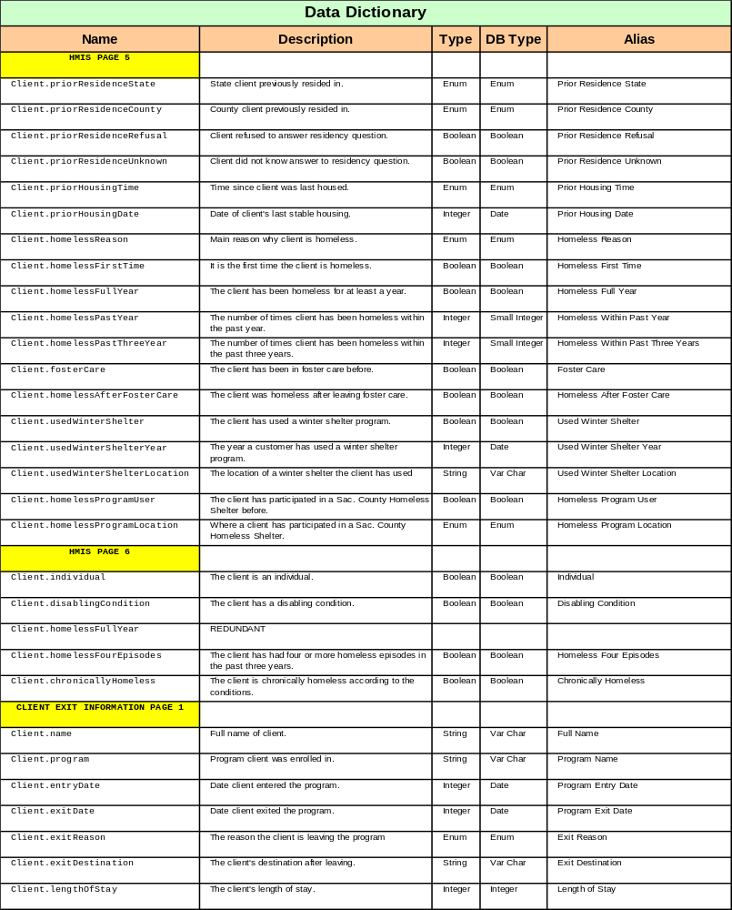

Non-Functional Requirements

- Approximately 3-5 simultaneous users
- Reasonable₃ query response time
- Current server should be able to store (up to) 18 months of data
- Approximately 10-20 client transactions per day
- Approximately 100 donor transactions per day
- No access outside of local intranet

Other Requirements

N/A

Object Oriented Analysis (OOA) –UML

In this document we utilize Unified Modeling Language (UML) in order to specify, visualize, construct, and document the pertinent objects of our product (software system).

OOA

To complete our Object Oriented Analysis we completed the following sections: First we designed a use case diagram which models our system’s intended functionality (use cases) and its environment (actors) (see Section 4.1.1: Use Diagram), we then provided a description for each use case (see Section 4.1.2: Use Case Descriptions), and finally identified likely classes based on the use cases. (see Section 4.1.3: Potential Classes)

Use Case Diagram

In its simplest terms, a use-case model is “a model that describes a system’s functional requirements in terms of use cases.” (Salem)

Below we provide a use case diagram in an attempt to shore up a mutual understanding of the requirements for the end users of our system (product). Furthermore, the following use case should accomplish the following:

- Identify…
  - Who interacts with the system and what the system should do.
  - The interfaces the system should have.

- Verify…
  - All requirements have been captured.
  - That JHA Software understands the requirements.

Figure 4.1.1-4: Use Case Diagram

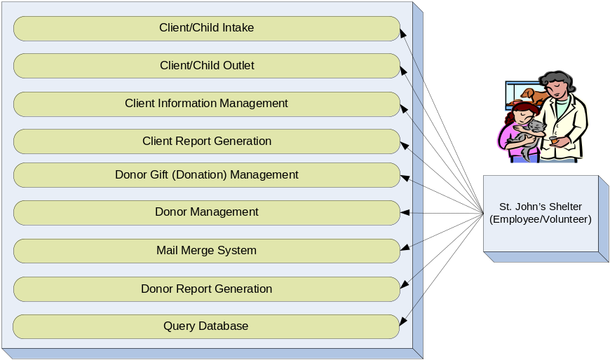

Use Case Descriptions

Now that we’ve defined our use cases, for ease of translation—in natural language—we will now provide a delineated description of each one.

Client/Child Intake

- Use Case Name: Client/Child Intake
- Use Case Number: UC1.1
- Author(s): Mike Aboushanab
- Actor(s): SJS Employee
- Overview: This use case captures the process of the intake of new and returning clients/children.
- Reference(s): R1.1
- Related Use Case(s): UC1.2, UC1.3

Typical Flow Description:

Figure 4.1.2.1.1-5: Typical flow of Client/Child Intake
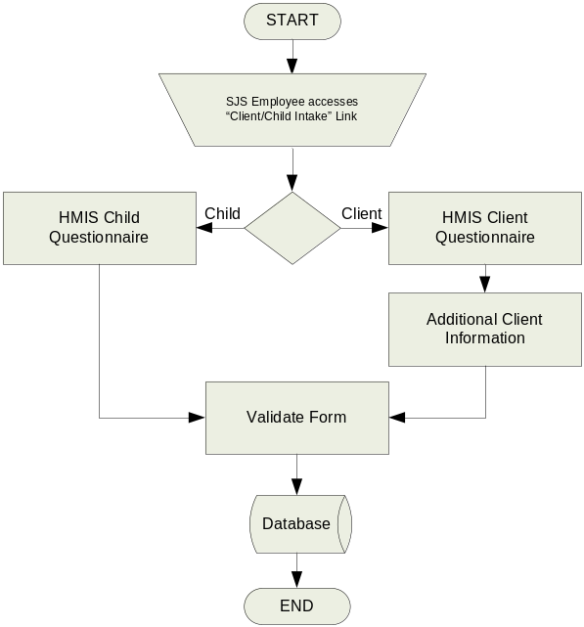

Alternative Flow Description:

Figure 4.1.2.1.2-6: Alternative flow of Client/Child Intake
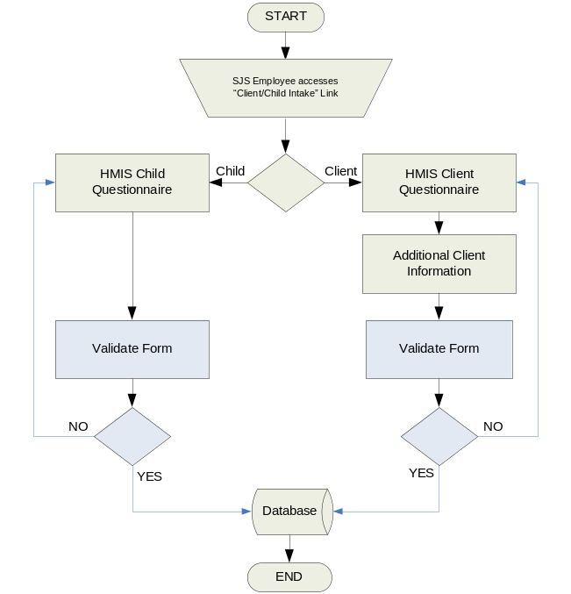

Client/Child Outlet

- Use Case Name: Client/Child Outlet
- Use Case Number: UC1.2
- Author(s): Mike Aboushanab
- Actor(s): SJS Employee
- Overview: This use case captures the process of the outlet of clients/children.
- Reference(s): R1.2
- Related Use Case(s): UC1.1, UC1.3

Typical Flow Description:

Figure 4.1.2.2.1-7: Typical flow of Client/Child Outlet
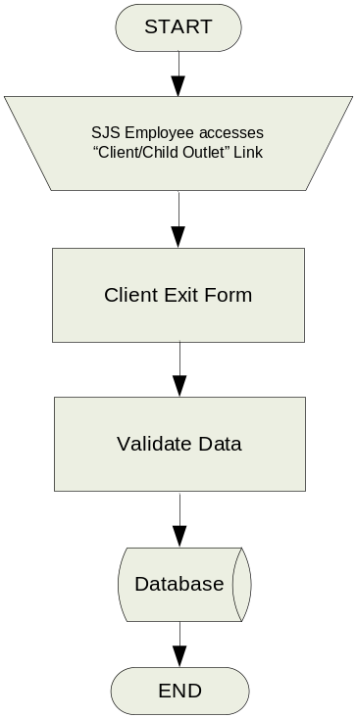

Alternative Flow Description:

Figure 4.1.2.2.2-8: Alternative flow of Client/Child Outlet
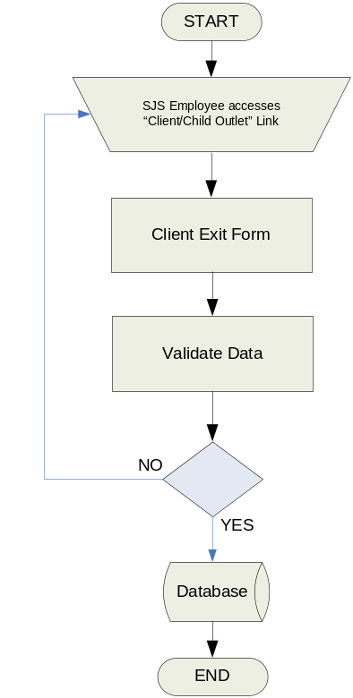

Client Information Management

- Use Case Name: Client Information Management
- Use Case Number: UC1.3
- Author(s): Mike Aboushanab
- Actor(s): SJS Employee
- Overview: This use case captures the process of managing the stored information of clients.
- Reference(s): R1.1, R1.2
- Related Use Case(s): UC1.1, UC1.2, UC3

Typical Flow Description:

Figure 4.1.2.3.1-9: Typical flow of Client Information Management
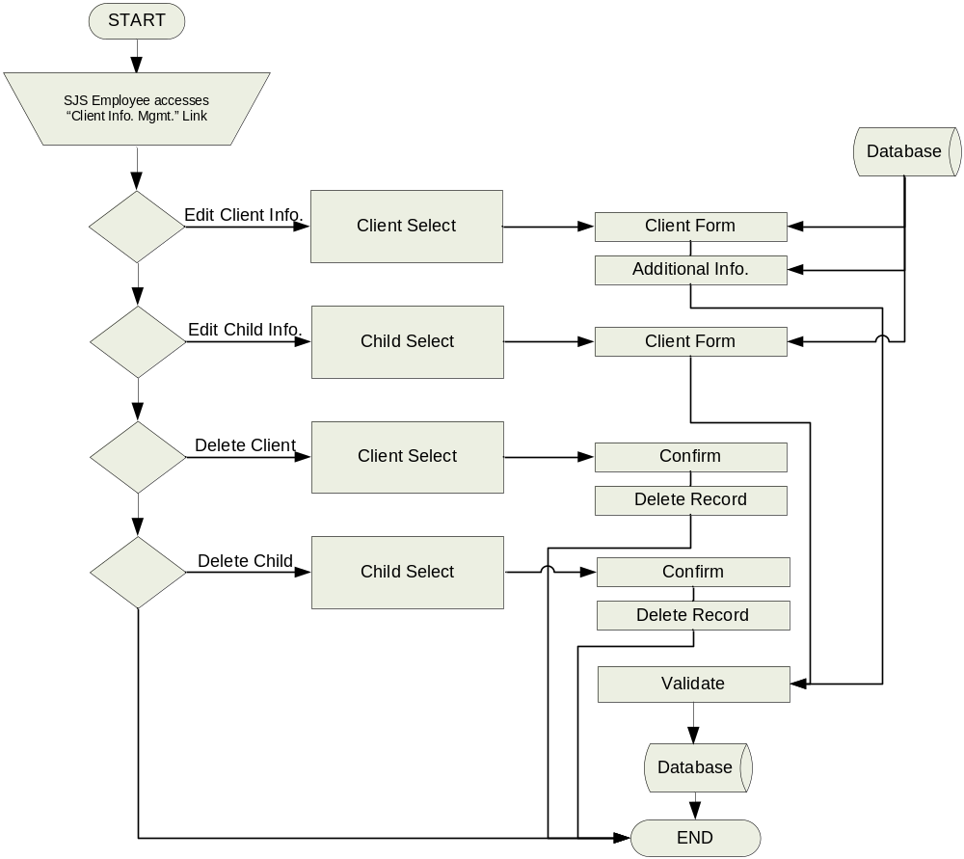

Alternative Flow Description:

Figure 4.1.2.3.2-10: Alternative flow of Client Information Management
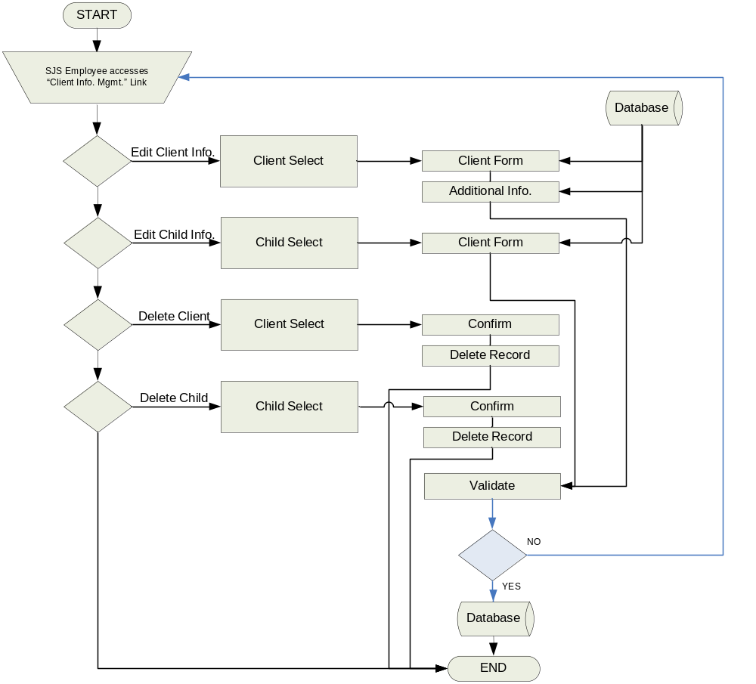

Client Report Generation

- Use Case Name: Client Report Generation
- Use Case Number: UC1.4
- Author(s): Mike Aboushanab
- Actor(s): SJS Employee
- Overview: This use case captures the process of the generation of client reports.
- Reference(s): R1.1, R1.2, R1.3
- Related Use Case(s): UC1.1, UC1.2, UC1.3

Typical Flow Description:

Figure 4.1.2.4.1-11: Typical flow of Client Report Generation
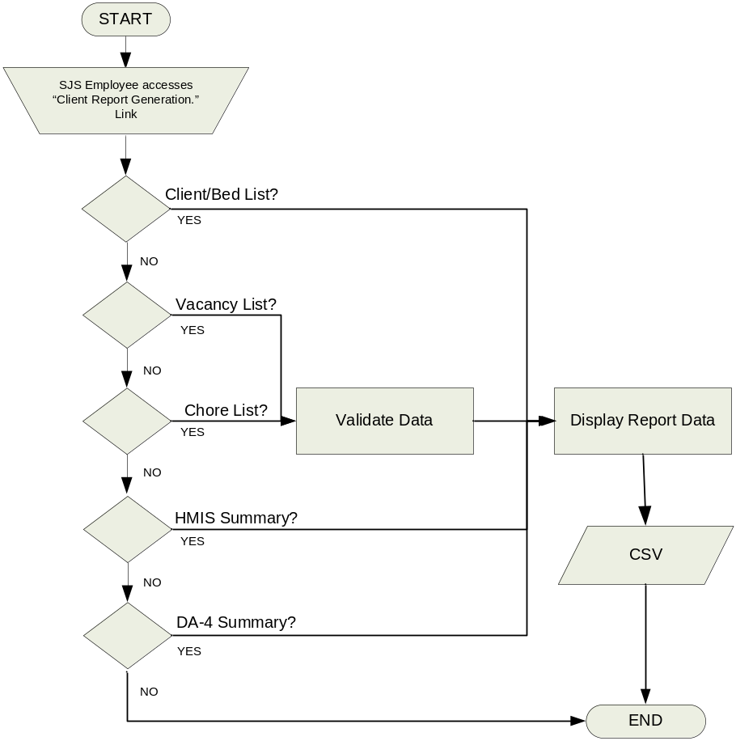

Alternative Flow Description:

Figure 4.1.2.4.2-12: Alternative flow of Client Report Generation
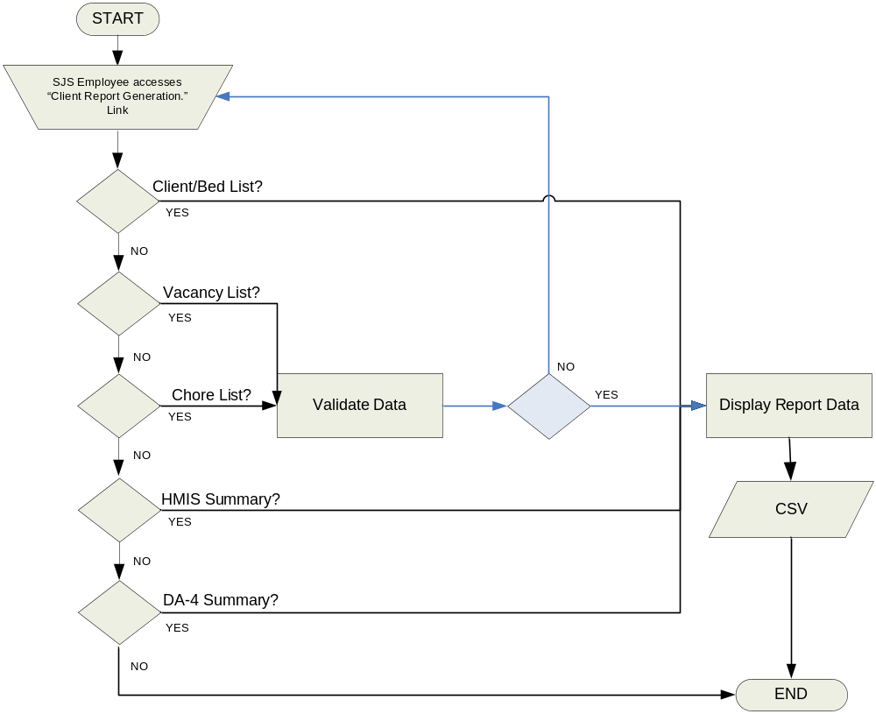

Donor Gift (Donation) Management

- Use Case Name: Donor Gift (Donation) Management
- Use Case Number: UC2.1
- Author(s): Matthew Hyatt
- Actor(s): SJS Employee
- Overview: This use case captures the process of the managing of gift information as such pertains to a specific (individual/group) donor.
- Reference(s): R2.1
- Related Use Case(s): UC2.2, UC2.3

Typical Flow Description:

Figure 4.1.2.5.1-13: Typical flow of Donor Gift Management
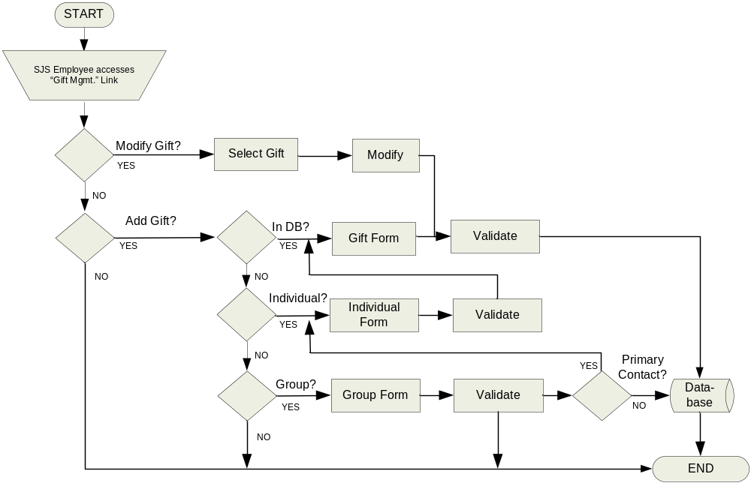

Alternative Flow Description:

Figure 4.1.2.5.2-14: Alternative flow of Donor Gift Management
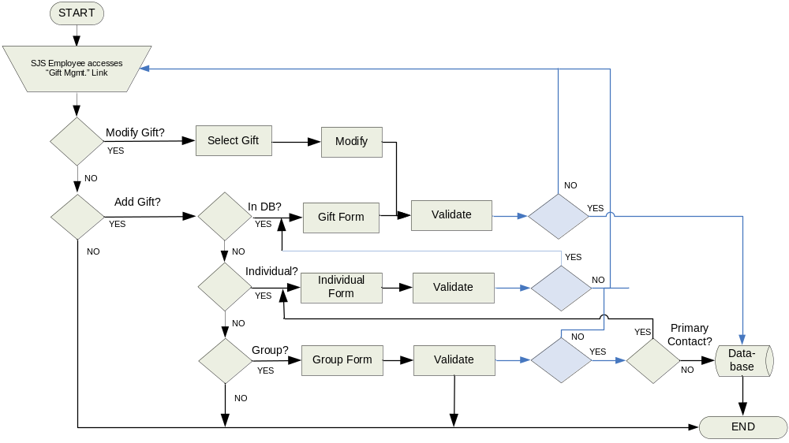

Donor Management

- Use Case Name: Donor Management
- Use Case Number: UC2.2
- Author(s): Matthew Hyatt
- Actor(s): SJS Employee
- Overview: This use case captures the process of the managing of donor information.
- Reference(s): R2.2
- Related Use Case(s): UC2.1, UC2.3, UC3

Typical Flow Description:

Figure 4.1.2.6.1-15: Typical flow of Donor Management
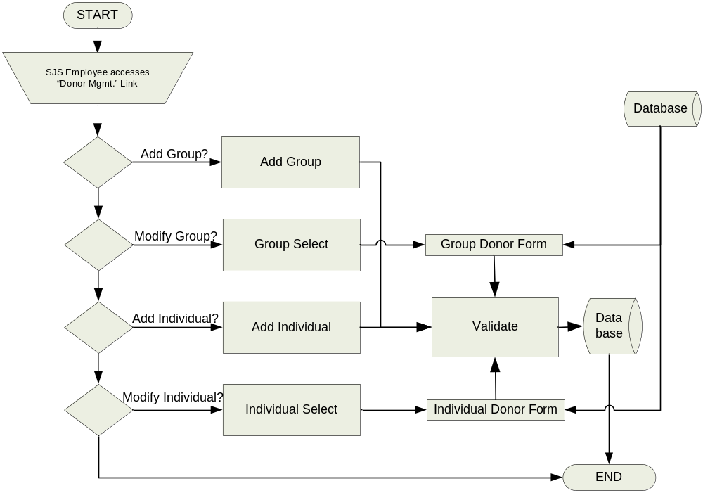

Alternative Flow Description:

Figure 4.1.2.6.2-16: Alternative flow of Donor Management
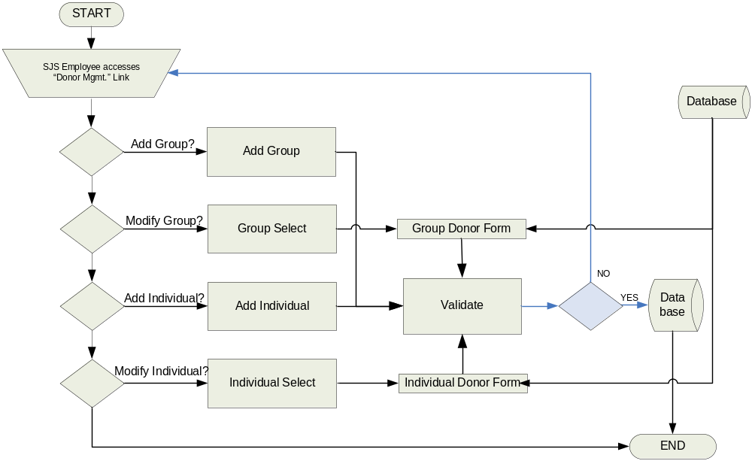

Mail Merge System

- Use Case Name: Mail Merge System
- Use Case Number: UC2.3
- Author(s): Matthew Hyatt
- Actor(s): SJS Employee
- Overview: This use case captures the process of the creation of mail merges based on data from the donor database.
- Reference(s): R2.3
- Related Use Case(s): UC2.1, UC2.2

Typical Flow Description:

Figure 4.1.2.7.1-17: Typical flow of Mail Merge System
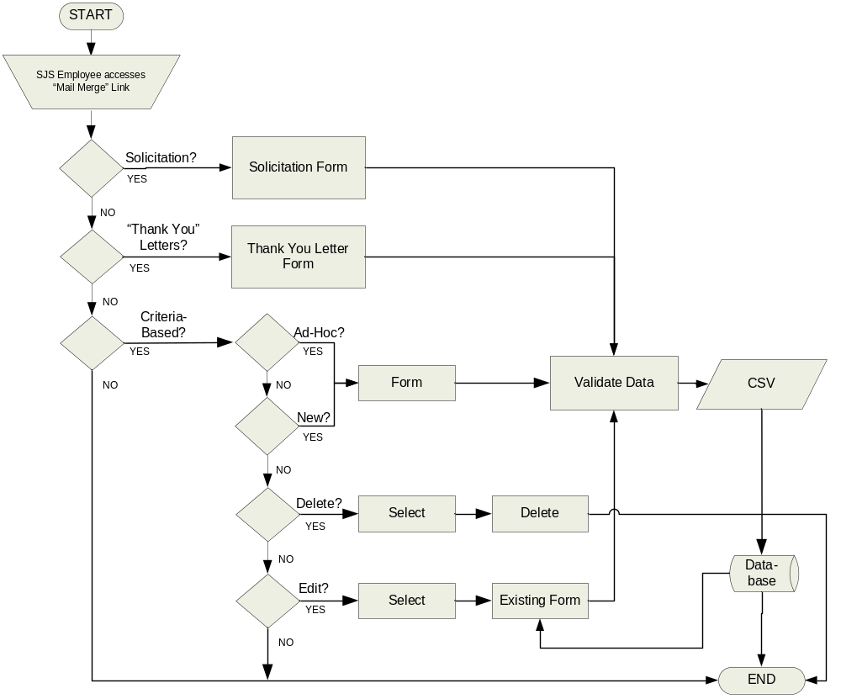

Alternative Flow Description:

Figure 4.1.2.7.2-18: Alternative flow of Mail Merge System
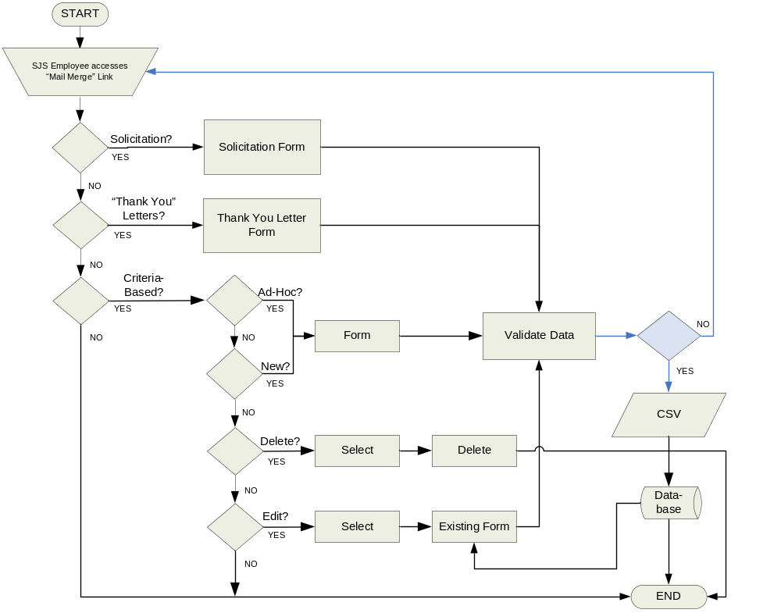

Donor Report Generation

- Use Case Name: Donor Report Generation
- Use Case Number: UC2.4
- Author(s): Matthew Hyatt
- Actor(s): SJS Employee
- Overview: This use case captures the process of the generation of donor reports.
- Reference(s): R2.4
- Related Use Case(s): UC2.1, UC2.2, UC2.3

Typical Flow Description:

Figure 4.1.2.8.1-19: Typical flow of Donor Report Generation
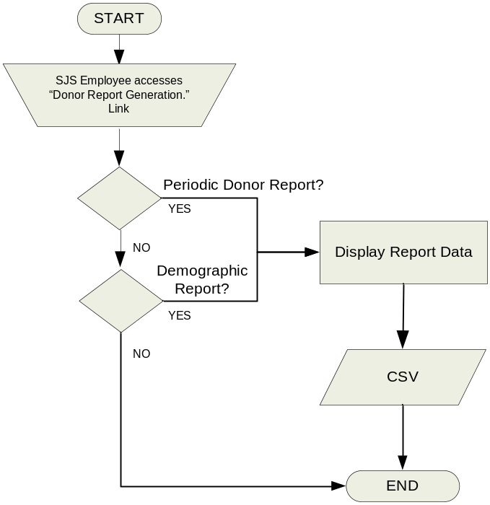

Alternative Flow Description:

N/A

Query Database

- Use Case Name: Query Database
- Use Case Number: UC3
- Author(s): Matthew Hyatt
- Actor(s): SJS Employee
- Overview: This use case captures the process of query management as well as querying the database and displaying the results.
- Reference(s): R1.4, R2.5
- Related Use Case(s): UC1.3, UC2.2

Typical Flow Description:

Figure 4.1.2.9.1-20: Typical flow of Query Database
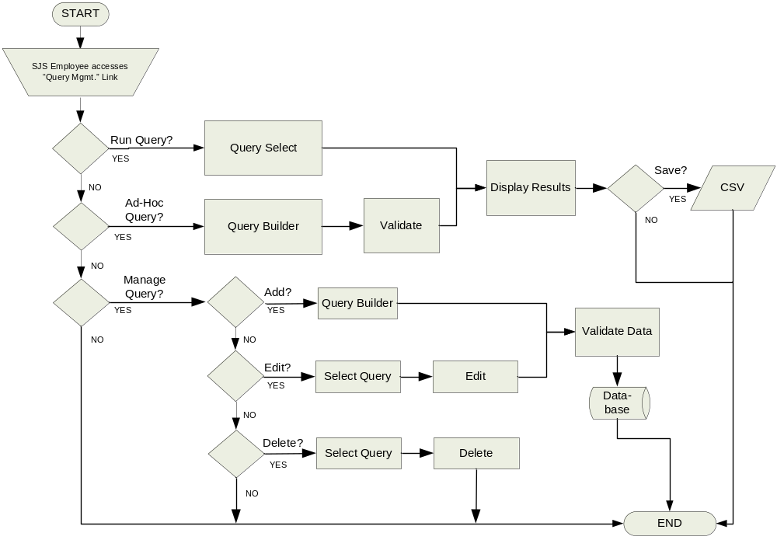

Alternative Flow Description:

Figure 4.1.2.9.2-21: Alternative flow of Query Database
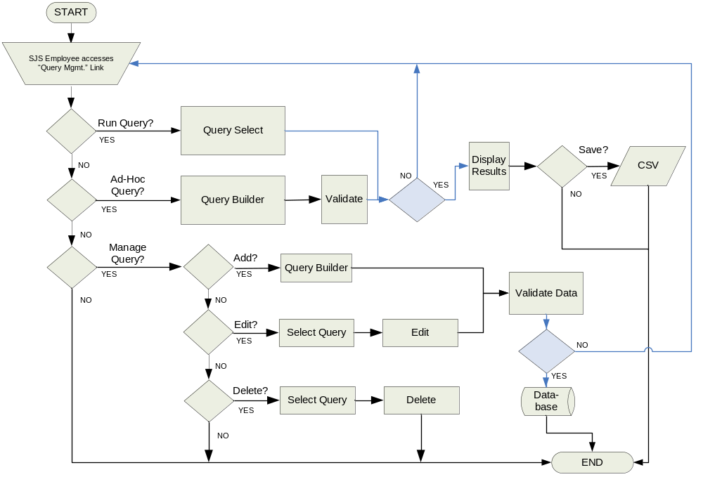

Potential Classes

Pressman defines a class as “a description of a set of objects that share the same attributes, operations, relationships, and semantics” (166). We define the following as the likely classes of our system:

Client

This class contains the data from the HMIS Client Questionnaire as well as additional client information necessary for generating the client list, vacancy list, chore list, room list, HMIS report, and the DA-4 report. This class will contain the methods to display the input forms, store and retrieve data from the database, and validate that information.

Child

This class contains the data from the HMIS Child Questionnaire necessary for generating the HMIS report, and the DA-4 report. This class will contain the methods to display the input forms, store and retrieve data from the database, and validate that information.

Individual Donor

This class contains the data from the individual donor information form, associations with group donors and gifts necessary for mail merges as well as donor report generation. This class will contain the methods to display the input forms, store and retrieve data from the database, and validate that information.

Group Donor

This class contains the data from the group donor information form, associations with individual donors and gifts necessary for mail merges as well as donor report generation. This class will contain the methods to display the input forms, store and retrieve data from the database, and validate that information.

Report

This class contains the data from the client/donor database necessary to generate reports. This class will contain the methods to display the reports, store and retrieve data from the database, and validate that information.

Gift

This class contains the data from the gift form as well as associations with individual/group donors necessary for donor gift report generation. This class will contain the methods to display the input forms, store and retrieve data from the database, and validate that information.

WBS

Table 5-2: Work Breakdown Structure
 | Team Lead | SW Engineer | QoS Engineer | Technical Writer
A. M.
H., M.
J. B.

Comments

Issues

- None at this time…

Notes

₁ More than 2-3 years old.

₂ Represented by an organization, etc., or just a group of individuals.

₃ Subjective to the task at hand, but in general within a few minutes (at most).

₄ Includes not only the verification/validation of all data values, and data types, but also the reporting of errors in the event that one of the preceding attributes is out of range.

References

Pressman, Roger S. Software Engineering: A Practitioner’s Approach. New York, NY: McGraw Hill,

Salem, Ahmed. “CSc 131: Object-Oriented Concepts and UML” Lecture. Department of Engineering and Computer Science, Sacramento State, USA. 3 March

Resources

Dictionary.com. <http://www.dictionary.com>.

